**Read the following instructions before completing the given task.  
  
Step 1: Click on the Online Task Link**

**Step 2: Download the document**

**Step 3: Check the online questions**

**Step 4: Complete the task and take a screenshot for each and every task and upload**

**Step 5: Save the document**

**Step 6: Upload the document in Google form**

**Assignment 1.   
  
   
1.) Frontend Application (1-hour task)**

**Task: Build a Weather Dashboard using a Public API.**

**Description: Create a simple weather dashboard that displays the current weather information for any city entered by the user. The data will be fetched from a free weather API (like OpenWeatherMap).**

**Upload the final output Screenshot**

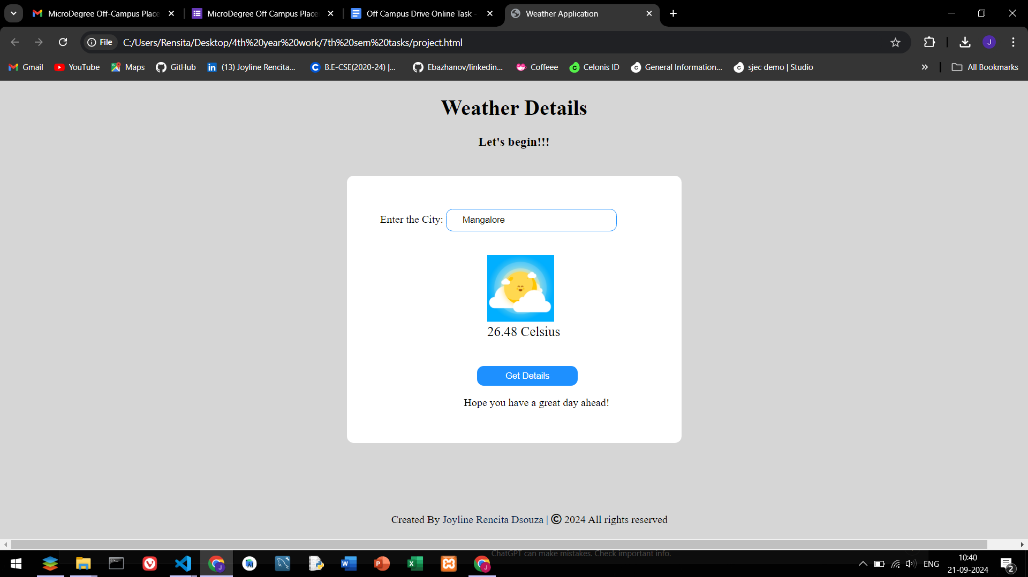

Live Demo : [**https://joyline-rencita-dsouza.github.io/weather-application/**](https://joyline-rencita-dsouza.github.io/weather-application/)

**Assignment 2.   
  
  
2.) Description: Assume you have a database with two tables: Students and Courses. Write SQL queries for the following (20 Mins):**

**Find the names of students who are enrolled in more than 2 courses.**

**List all students along with the courses they are enrolled in.**

**Update a student’s name who has a specific student ID.**

**Upload the final output Screenshot**

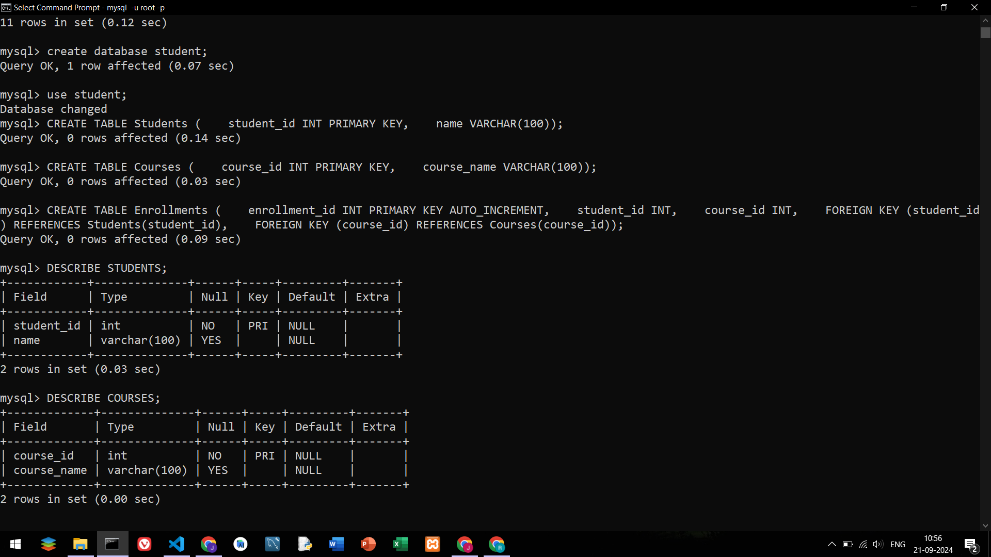

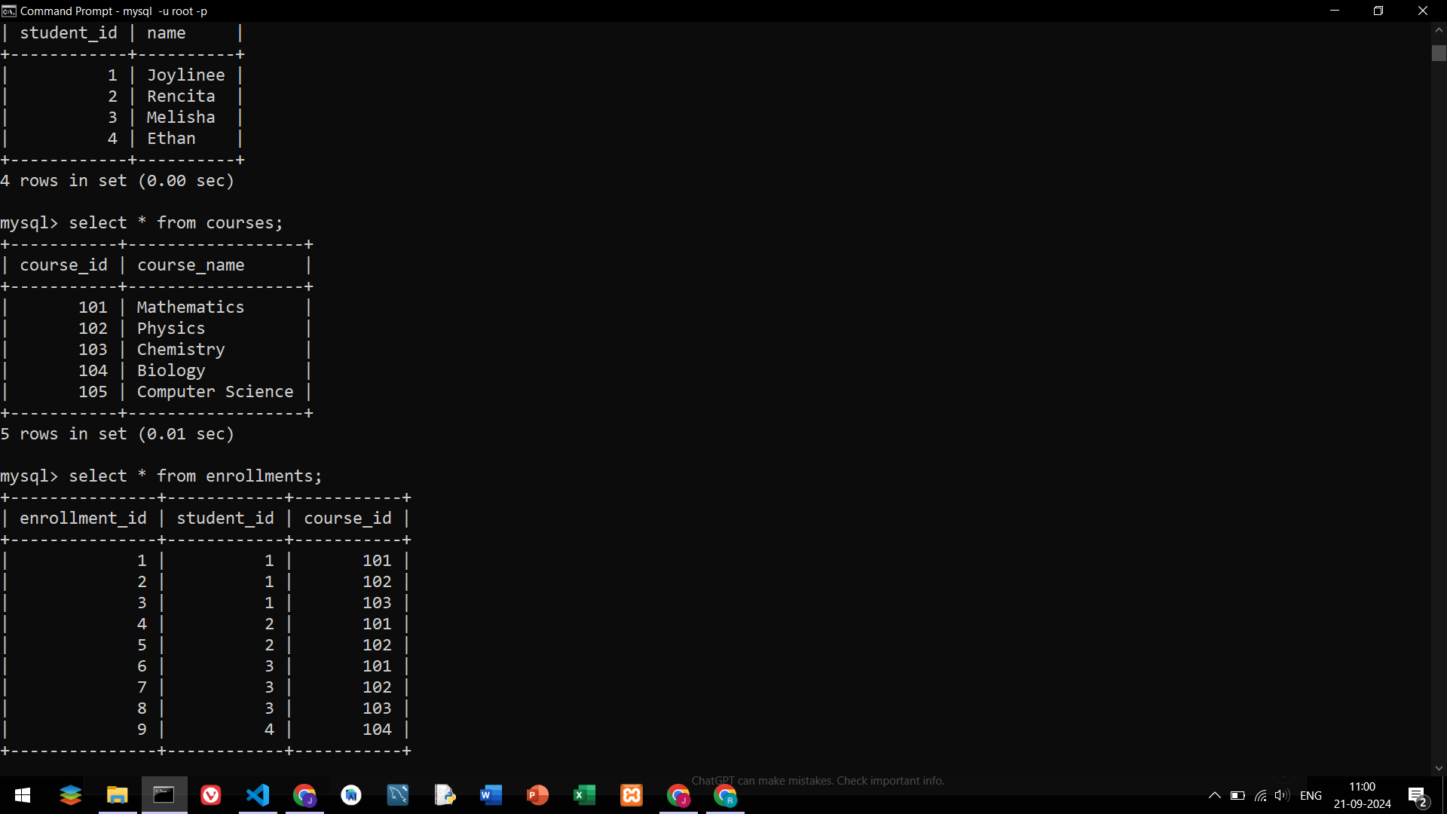

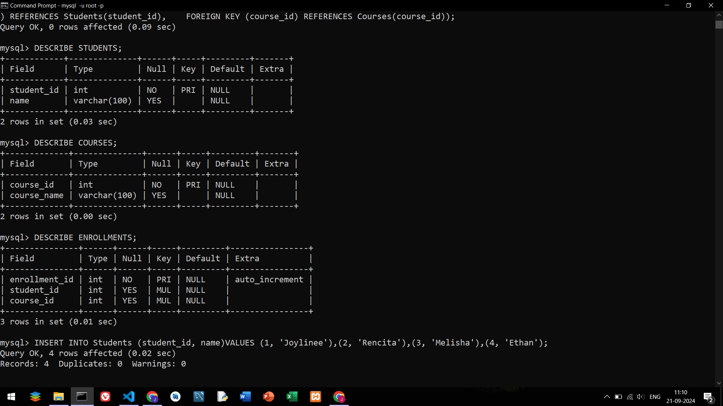

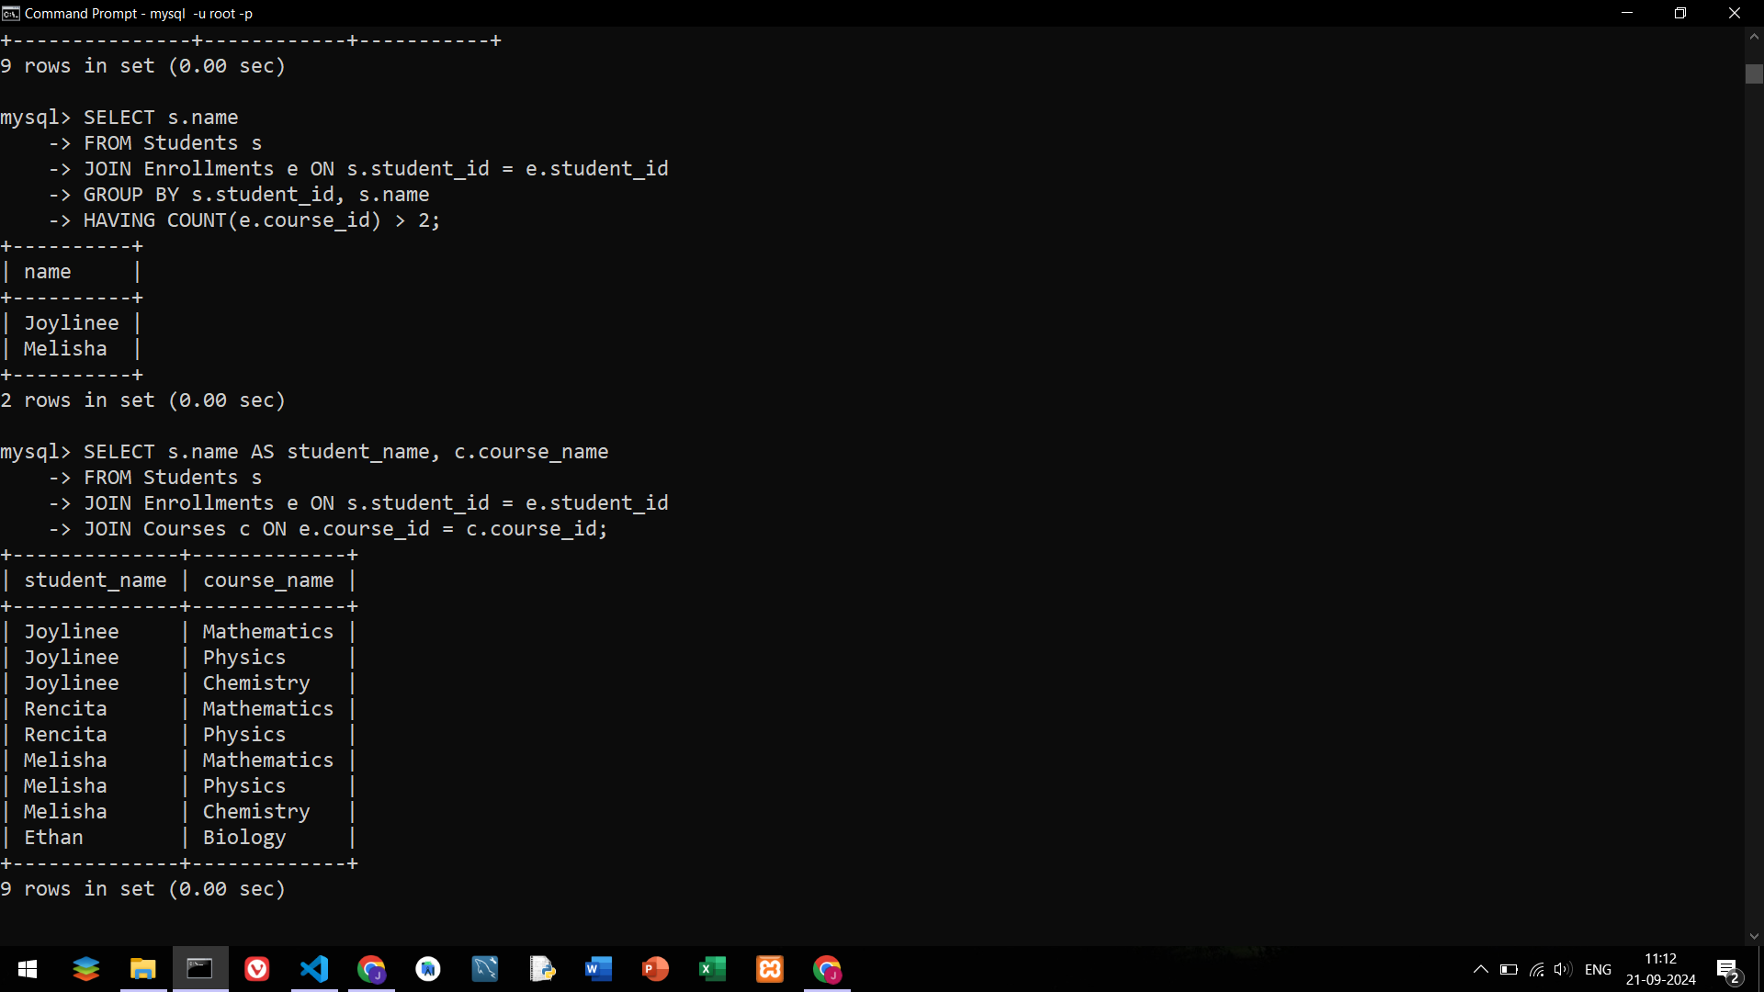

**Query Outputs :**



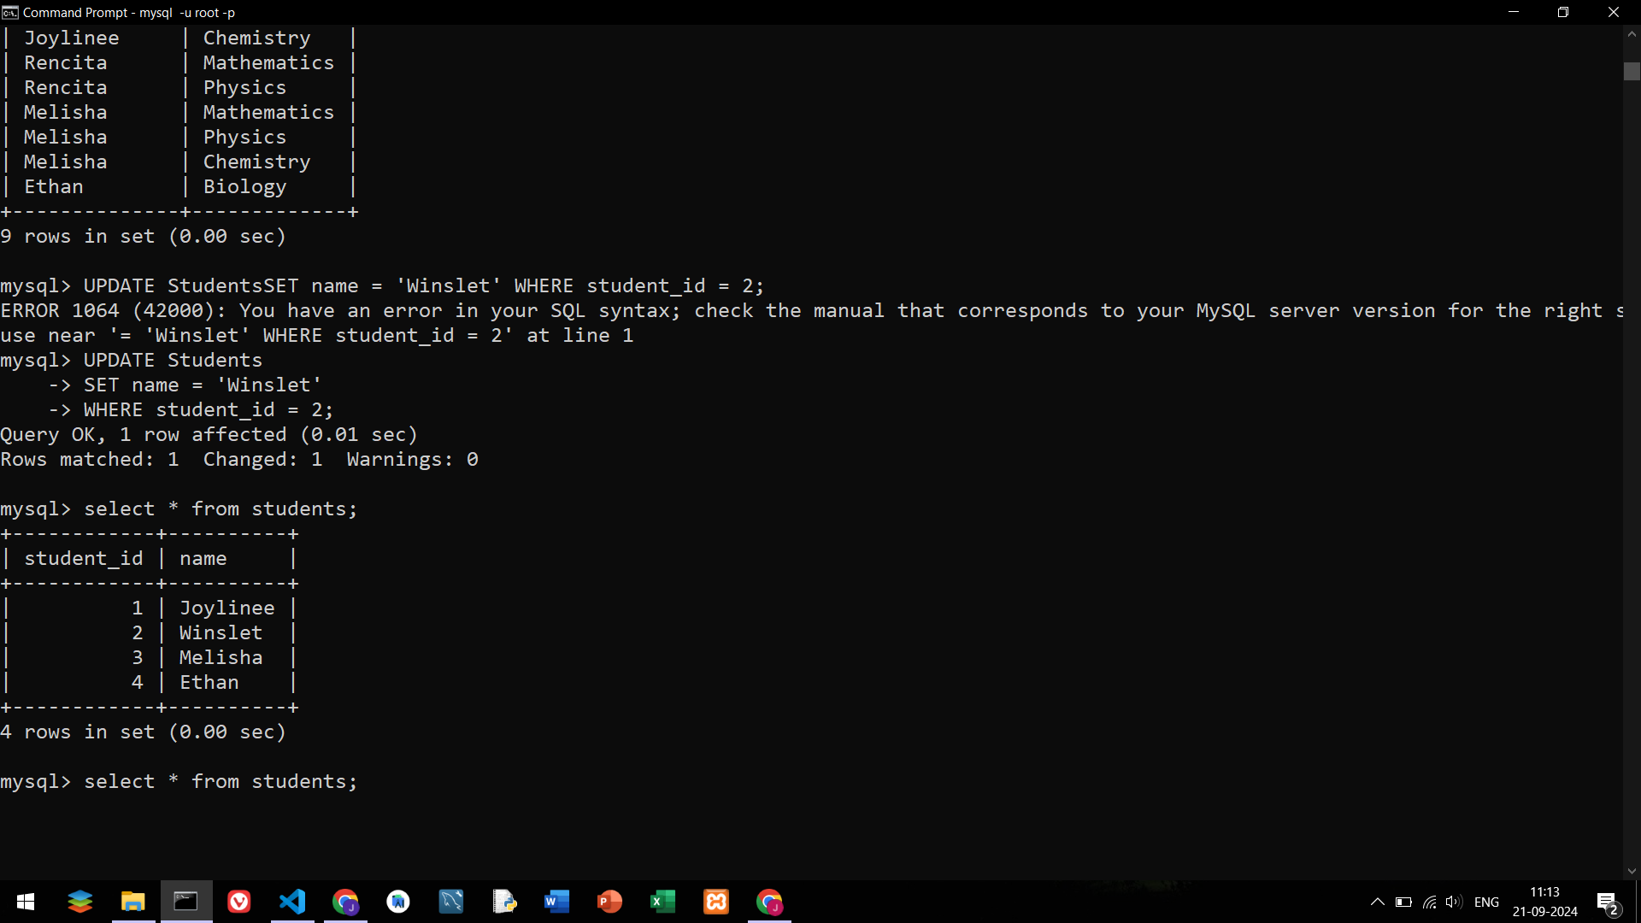

**Assignment 3.  
  
  
3.) Description: Write a Python script that acts as a task manager. The user should be able to:**

**Add a new task.**

**View all tasks.**

**Mark a task as completed.**

**Upload the final output Screenshot  
  
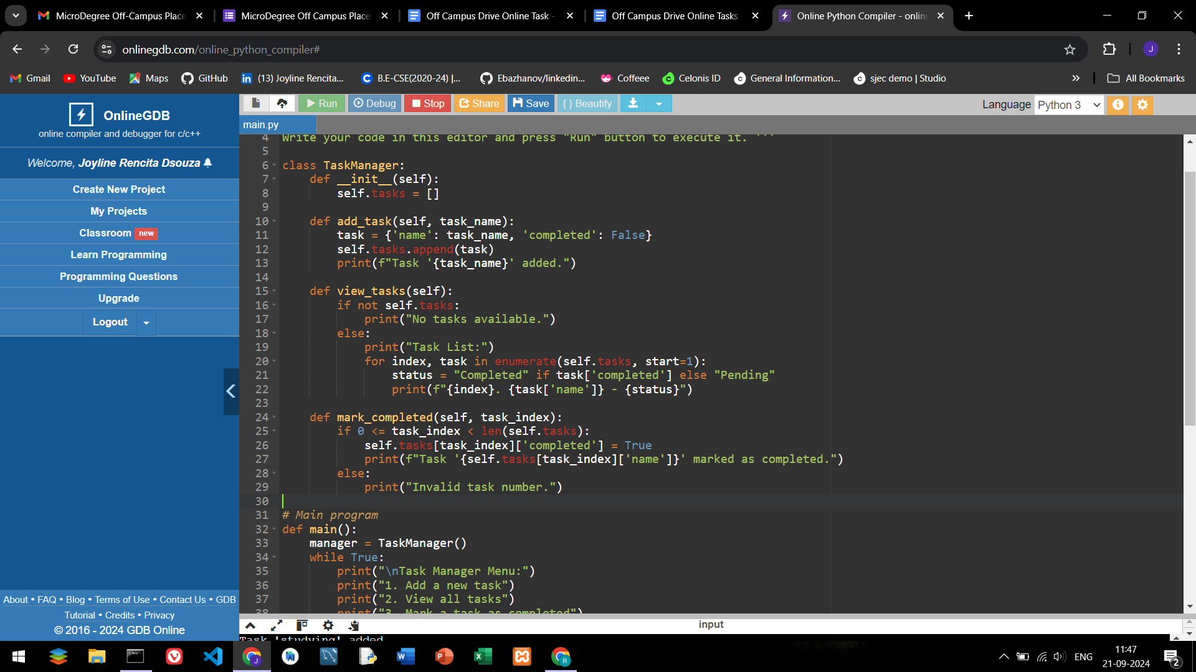**

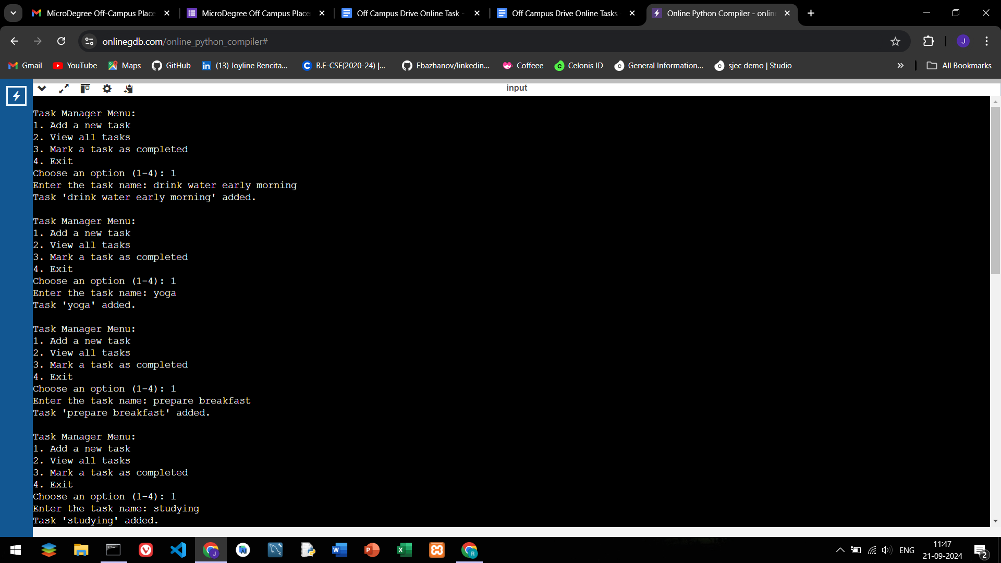

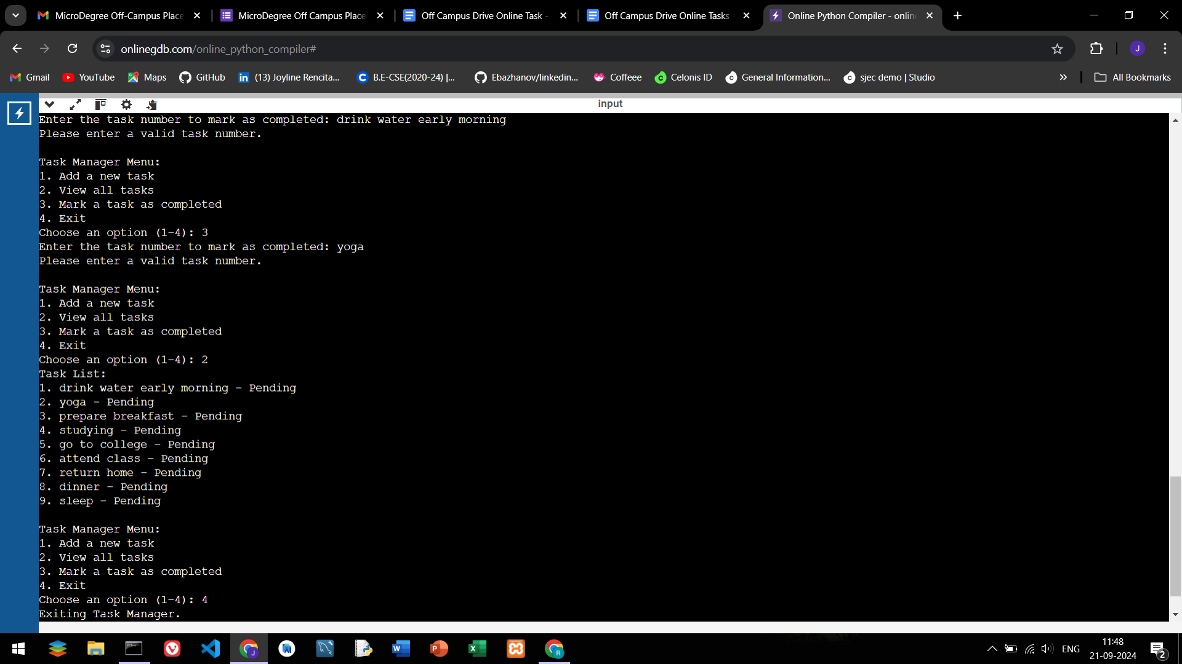

**Assignment 4.  
  
  
4.)Task: Create a Simple To-Do List Application.**

**Description: Build a basic to-do list using HTML, CSS, and JavaScript. The user should be able to:**

**Add a new task.**

**Mark a task as completed (strike-through the text).**

**Remove a task from the list.**

**Upload the final output Screenshot**

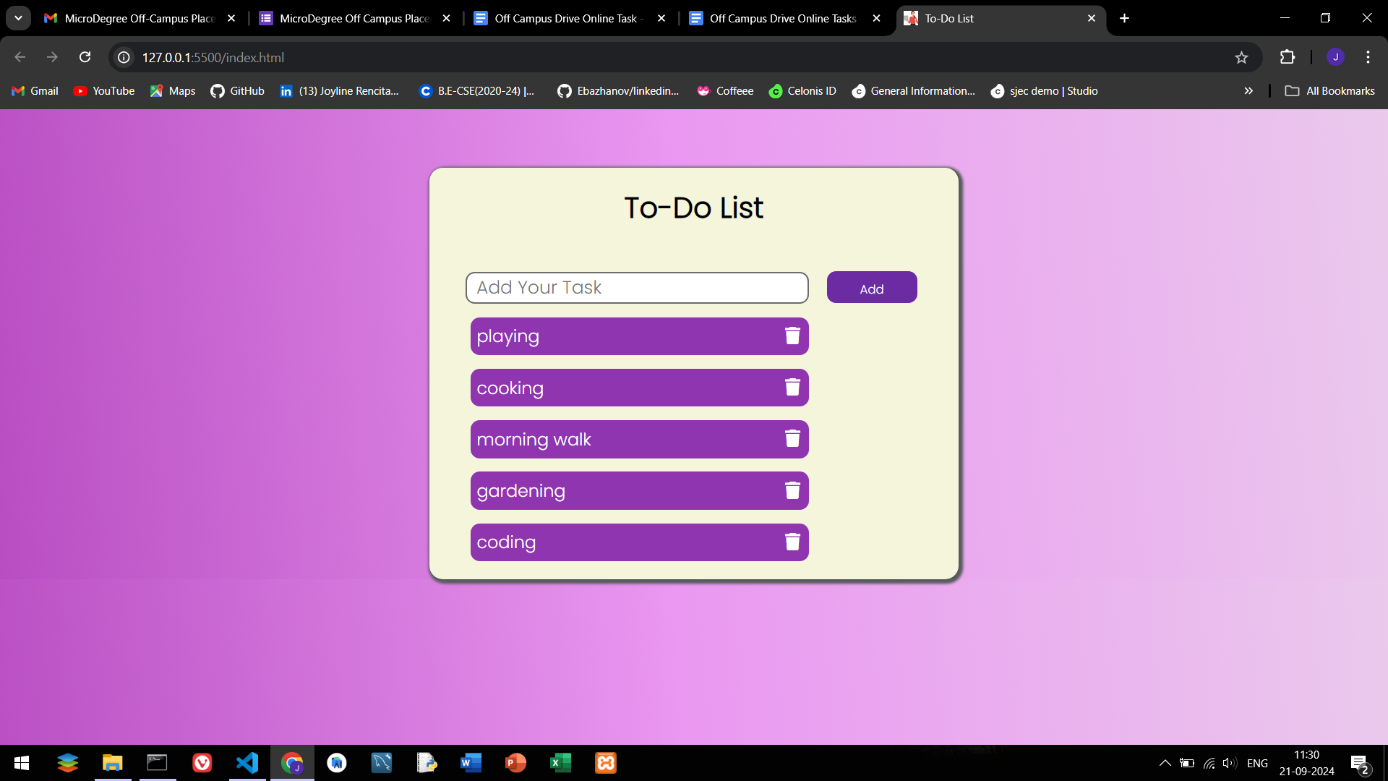

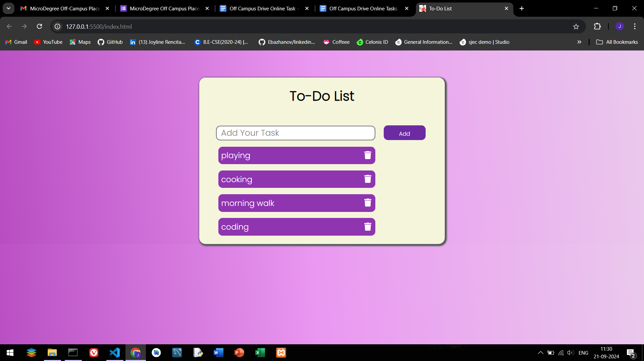

Live Demo : [**https://joyline-rencita-dsouza.github.io/To-Do-List/**](https://joyline-rencita-dsouza.github.io/To-Do-List/)

My Github : <https://github.com/Joyline-Rencita-Dsouza>